ICT701: Business Intelligence and Decision Support Systems
Assessment 1: Case Study Analysis

Table of Contents
1. Introduction 3
2. Knowing Retail Score Dataset 3
2.1 Branch and City Distribution 4
2.2 Payment and Product Line Insight 5
3. Defining the DSS Components 5
4. Data Integration & Transformation 6
4.1 Data Ingestion and Pipeline 6
4.2 Data Quality and Cleansing 6
4.3 Feature Engineering 7
4.4 Normalisation and Encoding 7
5. Algorithms and Tools of Analysis 7
5.1 Descriptive Analytics 8
5.2 Time-Series Forecasting 9
5.3 Customer Segmentation (K-Means Clustering) 10
5.4 Correlation and Regression Analysis 11
5.5 Apriori Algorithm Market Basket Analysis 12
6. User-Friendly Interface and Strategic Alignment 12
6.1 Dashboard Design 12
6.2 What-If Simulation 12
6.3 Strategic Alignment 13
6.4 Observing and Life-long Learning 13
7. Conclusion 13
References 14

1. Introduction
This has increased competition in the market because of the rapid growth of supermarkets in highly populated urban centres making data-driven decision-making an essential strategic competitive advantage. The report provides the design of a detailed Decision Support System (DSS) of a supermarket chain with three branches that include Branch X (Geelong), Branch Y (Melbourne), and Branch Z (Ballarat) on the basis of a real transactional dataset of 1,000 sales records taken during the period between January and December 2022. The definition of a DSS is an interactive computer based system that facilitates structured and semi structured decision making by bringing together data, analytical models and user friendly interfaces [1].
The dataset involves 17 variables such as product line, customer demographics, method of payment, pricing and customer satisfaction rating. The proposed DSS converts this raw data into an actionable business intelligence by five interconnected subsections namely: dataset understanding, DSS architecture, data integration and transformation, analytical modelling, and a user-friendly strategic interface. All these features allow retail managers to make evidence-based choices regarding inventory and marketing, as well as customer experience disciplines, that lie at the core of the business intelligence today [2].

2. Knowing Retail Score Dataset
The dataset documents point-of-sale transactions on 3 branches and 6 lines of products: Electronic accessories, Fashion accessories, Food and beverages, Health and beauty, Home and lifestyle and Sports and travel. The sample data were drawn on three cities in Victoria, Australia and Branch X in Geelong (340 transactions), Branch Y in Melbourne (332 transactions), and Branch Z in Ballarat (328 transactions). The critical beginning of any DSS is to understand the variables and framework of such a dataset so that it is meaningful in relation to the business [3].
Table 1: Descriptive Statistics of Key Numerical Variables
Variable | Min | Mean | Median | Max | Std Dev
Unit Price ($) | 10.58 | 56.17 | 55.73 | 100.46 | 26.49
Quantity (units) | 1 | 5.51 | 5 | 10 | 2.92
Total Transaction ($) | 11.18 | 325.72 | 257.26 | 1,047.65 | 246.92
Gross Income ($) | 0.53 | 15.52 | 12.26 | 49.90 | 11.76
Customer Rating (1–10) | 4.0 | 6.97 | 7.0 | 10.0 | 1.72
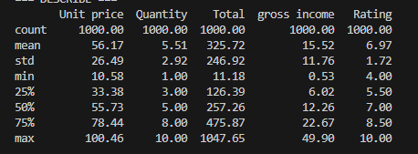
Table 1 shows that the customer base was heterogeneous with an average value of transaction at $325.72 (standard deviation of 246.92), which means that there was a wide variation in spending behaviour. The gross margin percentage is constant at 4.76% in all the 1,000 transactions, indicating that it maintains a steady pricing policy. The overall customer satisfaction is moderate to high as there is a customer satisfaction rating between 4.0 and 10.0 with a mean of 6.97.

2.1 Branch and City Distribution
Branch Z (Ballarat) has the largest total revenue but the least number of transactions (328), which implies that the mean basket sizes are bigger. Branch X (Geelong, $ 107,130) and Branch Y (Melbourne, 107,108) are almost identical. The customer satisfaction rate in branches is as shown below: X: 7.03, Y: 6.82, Z: 7.07 and it shows that the service delivery in the country is equal. The customer satisfaction rating is similar across branches as follows: X: 7.03, Y: 6.82, Z: 7.07, which indicates that service delivery throughout the country is equal. This almost homogenous distribution is significant: the DSS must be focused on product-mix and segment optimisation, but not on reallocation of resources per branch [4].

2.2 Payment and Product Line Insight
The highest grossing product line is food and beverages at $56,621, then at Sports and travel, which at 55,583, and finally the electronic accessories at 54,823. Health and beauty earns the least income of $49,621, partially because it has the least number of transactions (152 out of 1,000). There is a close balance in the usage of payment methods, with Ewallet (34.5%), Cash (34.4%), Credit card (31.1%) coming third, fourth and fifth respectively, proving that all three payment methods should be equally supported when it comes to analytics and promotional targeting.

3. Defining the DSS Components
A Decision Support System is the combination of data and analytical models and interactive interfaces to help managers in the semi-structured problems [5]. The proposed DSS has four closely interconnected layers as discussed in Table 2.
Table 2: Components of DSS Architecture
Component | Technology Stack | Major Functions
Data Layer | PostgreSQL / AWS RDS | All the transactional, product, and customer data centralized on one server; nightly ETL with POS systems.
Analytical Layer | Python (pandas, scikit-learn, Statsmodels) | Object Statistical modeling, machine learning, forecasting and what-if simulation engine.
Reporting Layer | Power BI / Matplotlib / Seaborn | Automated PDF and Excel reports, interactive dashboards, KPI scorecards.
User Interface | React.js Web Application | Role-based web portal with customized views to store managers and regional executives.
The interface layer offers role-based access that is personalised - store managers can have access to operational metrics at the branch level, whereas regional executives can access cross-branch strategic analytics (Provost and Fawcett, 2013).

4. Data Integration & Transformation

4.1 Data Ingestion and Pipeline
The Excel source file is automatically loaded into the centralised PostgreSQL database with the help of an ETL pipeline. In order to facilitate operational deployment, real-time POS transactions are fed by using Apache Kafka message queues, where data are available on the same day. Any DSS requires data integration as a basic requirement in order to work reliably [6].

4.2 Data Quality and Cleansing
The current dataset has no missing values in all 17 variables, which proves a high source data integrity.
- Completeness - all 17 fields are required to be filled in per record,
- Deduplication - The invoice IDs are hash-checked
- Checking date fields - Date fields are converted into datetime objects and checking categorical fields against lists of allowed-values.
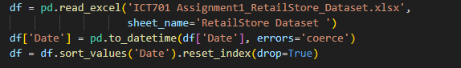
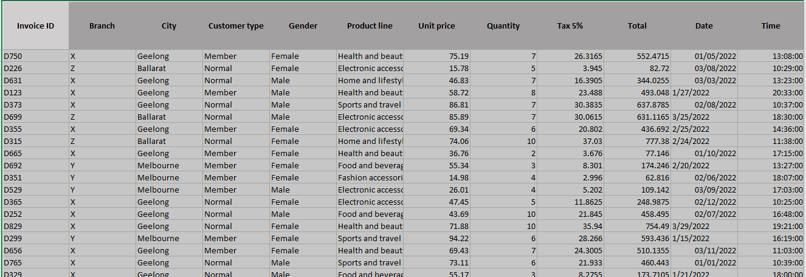

4.3 Feature Engineering
Several derived variables are made to give depth to the model:
- Hour-of-day = Time field against the Date field to model peak trading windows,
- Day-of-week = Date field against the Time field and Month field to capture time and seasonality,
- Revenue per unit = Total / Quantity to normalise the comparison of baskets; and
- High-value customer flag. These artificial capabilities enhance significantly the predictive quality of downstream segmentation and prediction model.

4.4 Normalisation and Encoding
Distance based algorithms (K-Means, KNN) are standardised by means of normalisation of continuous variables using Z-score before being run. Regression and neural models use one-hot encoded categorical variables, and the tree-based models use label-encoded (Random Forest, XGBoost).

5. Algorithms and Tools of Analysis
The DSS uses an analytic strategy that is layered using both descriptive, predictive, and prescriptive methods. The DSS design involves selecting and justifying proper analytical models [7].

5.1 Descriptive Analytics
All the descriptive analysis is based on Python (pandas), matplotlib, and seaborn libraries. Figure 1 indicates that the revenue is almost evenly distributed by branches (X: $107,130; Y: 107,108; Z: 111 484), Ewallet and Cash are the most popular payment methods.
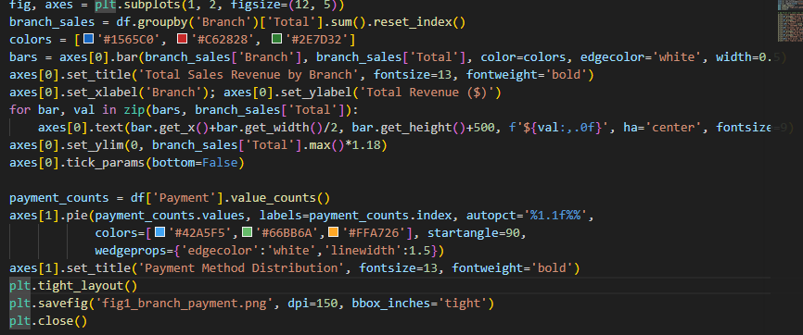
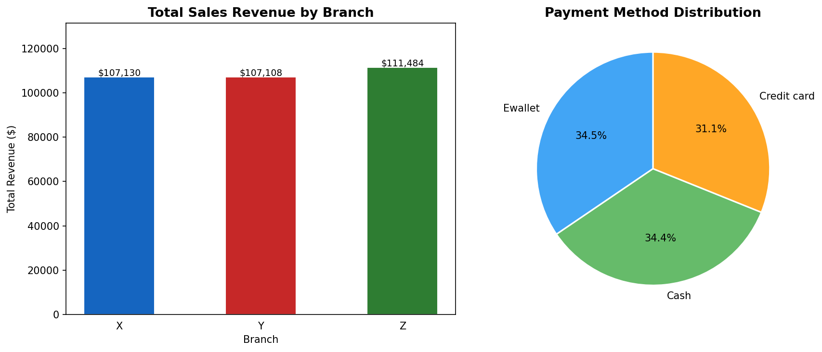
Figure 1: Branch Sales Revenue (Left) and Method of payment Distribution (Right)
Figure 2 indicates that Food and beverages cause the most revenue of $56,621 and Health and beauty is the least at 49, 621. Notably, there is slight change in customer ratings within lines of products (range: 6.84-7.11), which implies that the changes in revenues are fuelled by frequency of purchase and quantity of goods bought, but not by customer satisfaction. Specific volume promotion of the product is thus a better lever than the quality improvement of poorly performing lines.
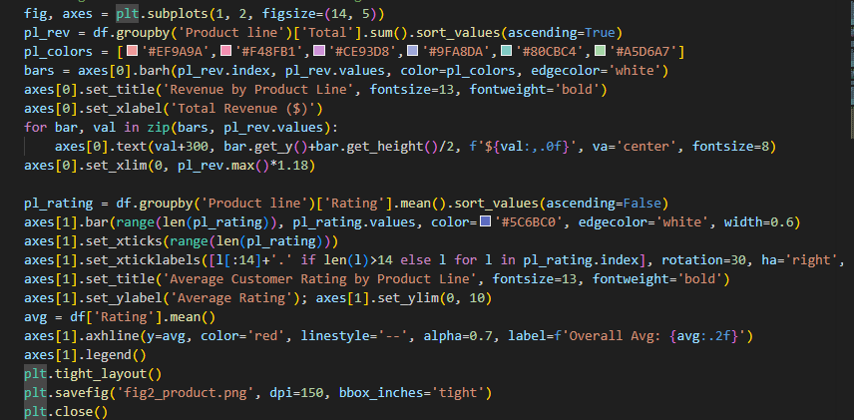
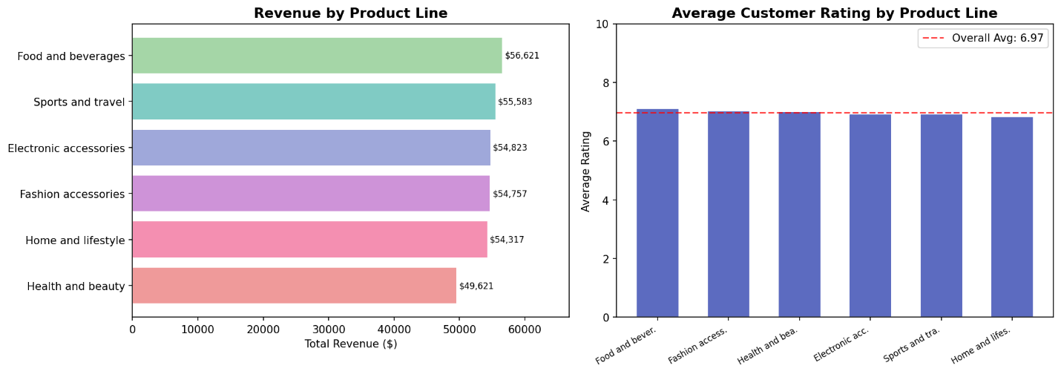
Fig. 2: Product Revenue by Product line (Left) and average Customer rating by Product line (Right)

5.2 Time-Series Forecasting
Figure 3 shows each branch sales trends monthly. Branch Z is recording a little higher revenue whereas all branches have a similar seasonality. This monthly series will be trained either in an ARIMA or Facebook Prophet model that will then generate next-quarter branch and product-line level demand forecasts to guide proactive inventory replenishment and staffing decisions. The customer-type break down proves that Member and normal customers are almost equally contributing to all product lines, which proves that the uptake of the loyalty programme is broad.
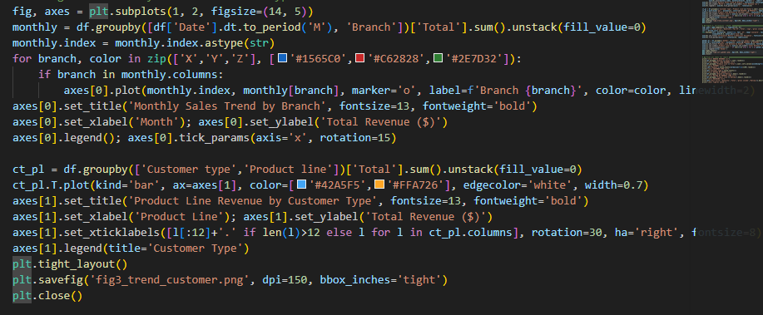
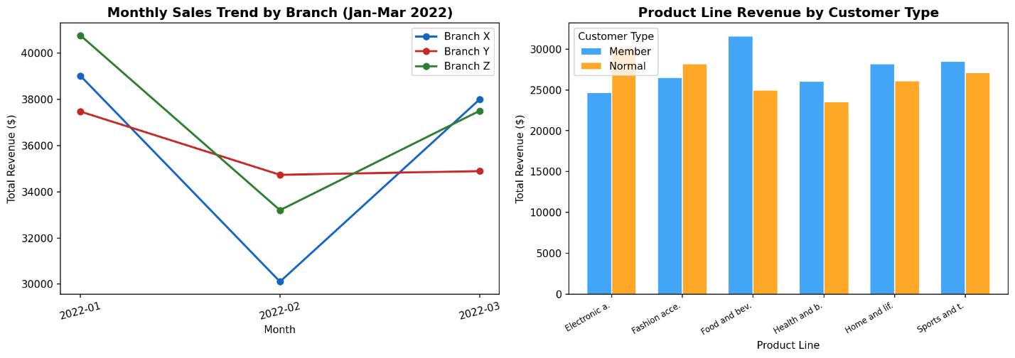
Figure 3: Sales Trend/Branch per month (Left) and Revenue/Customer type/Product line (Right)

5.3 Customer Segmentation (K-Means Clustering)
K-Means clustering: The elbow method and silhouette score will be used to determine the number of clusters; depending on the total spending, number of purchases made, the affinity of the product lines and the satisfaction score, customers will be grouped into clusters. The Member/Normal ratio of 501/499 is almost equal, indicating two natural macro-segments, however, sub-segmentation will expose more behavioural profiles.

5.4 Correlation and Regression Analysis
The correlation matrix is provided in figure 4. Total, COGS, Tax and Gross income have near-perfect correlated (r is greater than 0.99) because they are computed mathematically. There is modest positive correlation between Unit price and Quantity with Total ( r ≈ 0.70–0.80). More importantly, Rating has an almost zero correlation with all financial variables ( r < 0.05), showing that the level of spending is not a predictor of satisfaction. The model will be a multiple linear regression where the dependent variable will be Total in order to determine the relative contribution of each predictor to optimise prices [1][2].
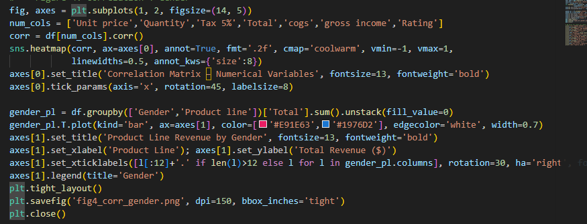
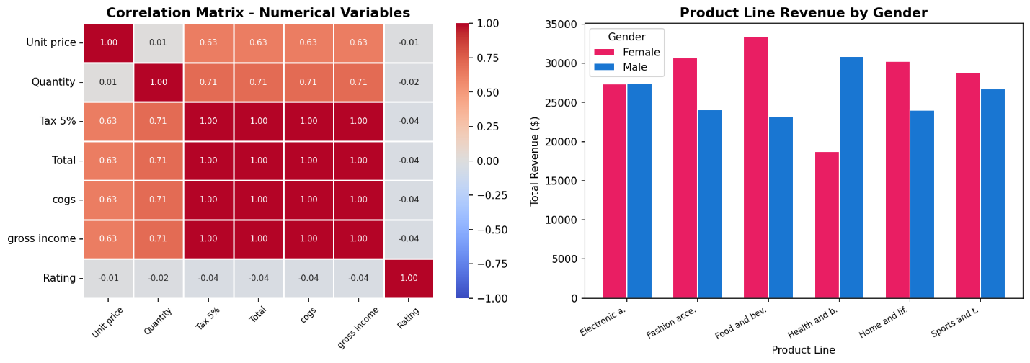
Figure 4: Correlation Matrix of Numerical Variables (Left) and Revenue by Gender per Product Line (Right)

5.5 Apriori Algorithm Market Basket Analysis
The association rule mining using the Apriori algorithm will be used to determine co-purchase patterns among product lines and payment-product combinations. Learning, e.g. that users of the Ewallet are overrepresented in the purchase of Electronic accessories would inform promotion of payments and product co-purchase regulations would facilitate cross-merchandising and shelf-placement optimisation [1][3].

6. User-Friendly Interface and Strategic Alignment

6.1 Dashboard Design
The DSS is constructed in the form of a web application, a responsive React.js based system, available on desktop and mobile. It utilizes role-based access control: the store managers can look at branch-level KPI tiles (Total Revenue, Gross Income, Average Rating, Transaction Count) that are updated on a daily basis, whereas cross-branch comparative analytics and forecasting panels are available to the regional executives. An important element of any decider interface is the effective visualisation of insights [1][3].

6.2 What-If Simulation
A scenario analysis module enables managers to simulate the effect of change in the revenue of the company due to either change in price or promotion discount prior to its implementation. An example: 'Assuming that we give out a 15 percent reduction on Health and beauty products, how the monthly revenue will be affected? The DSS executes a Monte Carlo simulation of the trained regression model, and provides a probability distribution of the outcomes, which measures the expected impact and the downside risk - and makes the system not merely a reporting tool but an actual decision-support system.

6.3 Strategic Alignment
The DSS is also aligned to three strategic goals.
- First, improvement of customer experience: the system can also track branch and product-line ratings in real time, and once the ratings are below a set threshold, this will automatically generate a workflow of customer feedback.
- Second, increase in revenue: the demand forecasts and customer segment propensity scores determine the best periods to target customers through campaigns and maximize ROI.
- Third, operational efficiency: the forecasting module produces inventory reorder suggestions that lead to low costs of stockouts and overstock, which directly decrease the COGS.

6.4 Observing and Life-long Learning
The DSS is not static. The weekly monitored model performance is held out and automated retraining pipelines update models on a rolling 90-day sequence where the forecast performance cannot meet the acceptable thresholds.

7. Conclusion
In this report, the decision support system of three branch supermarket chain in Victoria was presented using the real dataset of 1000 transactions. The analysis has shown three important lessons: Branch Z brings in the biggest revenue with a lesser number of transactions; the most profitable product line is Food and beverages whereas the least profitable is Health and beauty; the customer satisfaction ratings are independent of the spending level without statistical significance, which directly influences the formation of service strategy. The suggested DSS will incorporate a powerful ETL data pipeline, Python-based descriptive and predictive analytics, interactive Power BI dashboards, and what-if simulation facilities in a role-based web interface. The DSS can provide the retail chain with a sustainable competitive intelligence advantage when such capabilities are implemented along with strategic objectives of customer experience improvement, revenue growth and operational efficiency.

References
[1] Swathi_G, “The Difference between Business Intelligence and Decision Support System,” Medium, Feb. 12, 2024. https://medium.com/@swathigopalka/the-difference-between-business-intelligence-and-decision-support-system-59f14b57de6d
[2] Saeed Rouhani, “(PDF) The impact of business intelligence on decision support and organizational benefits,” ResearchGate, Mar. 25, 2023. https://www.researchgate.net/publication/277003403_The_impact_of_business_intelligence_on_decision_support_and_organizational_benefits
[3] GeeksforGeeks, “Data Integration in Data Mining,” GeeksforGeeks, Jun. 27, 2019. https://www.geeksforgeeks.org/machine-learning/data-integration-in-data-mining/
[4] M. A. P. Joshi and B. V. Patel, “Data Preprocessing: The Techniques for Preparing Clean and Quality Data for Data Analytics Process,” Oriental Journal of Computer Science and Technology, vol. 13, no. 2, 3, pp. 78–81, Jan. 2021, Available: https://www.computerscijournal.org/vol13no23/data-preprocessing-the-techniques-for-preparing-clean-and-quality-data-for-data-analytics-process/
[5] A. Clarke, “Advancing Organizational Decision-Making Through Decision Support Systems (Dss),” Journal of Management Information and Decision Sciences, vol. 28, no. 1, pp. 1–2, Dec. 2025, Accessed: Mar. 24, 2026. [Online]. Available: https://www.abacademies.org/articles/advancing-organizational-decisionmaking-through-decision-support-systems-dss-17779.html
[6] M. Kozielski, J. Henzel, Ł. Wróbel, Z. Łaskarzewski, and M. Sikora, “A Sensor Data-Driven Decision Support System for Liquefied Petroleum Gas Suppliers,” Applied Sciences, vol. 11, no. 8, p. 3474, Apr. 2021, doi: https://doi.org/10.3390/app11083474.
[7] F. Hak, T. Guimarães, and M. Santos, “Towards effective clinical decision support systems: A systematic review,” PLOS ONE, vol. 17, no. 8, Aug. 2022, doi: https://doi.org/10.1371/journal.pone.0272846.

